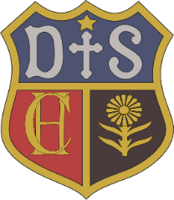

Charlton House Independent School
Science
Intent

Our vision for science at Charlton House Independent School is to promote the development of children’s natural curiosity about the world around them and to foster an appreciation of the importance of science so that they will develop an understanding of that world. We seek to promote and develop a sense of awe and wonder at the beauty and balance of God’s world. Children will develop their scientific learning through ambitious, inspirational and engaging hands-on lessons that relate to the world they know beyond the classroom. Children will question and use the full range of enquiry skills to plan, complete and analyse their own investigations that are sequenced and adapted to meet the needs of each child.

