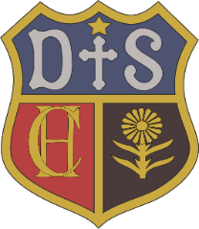

Charlton House Independent School
R.E.
Intent

At Charlton House Independent School, we want every child to be happy and enthusiastic learners of RE, and to be eager to achieve their very best in order to fulfil their God-given talents which is central to the life of our happy, caring school.
At Charlton House Independent School, we will enable each child to develop a deeper understanding of the Catholic faith, promote respect for religious and moral values and tolerance of other races and religions and foster the growth of each child’s potential through the development of respect for self and others. We will promote the individual talents and abilities of pupils to ensure that each child fulfils his or her full potential. We Promote an understanding and care of the environment in which each child finds him or herself.
In the school community we live by the motto: - “Love One Another”

Our principal aim is that children leave Charlton House Independent School with a wide range of happy and rich memories in RE formed through interesting and exciting experiences driven through an engaging and comprehensive curriculum which is the basis of knowledge and understanding of the Catholic faith, enabling them to develop a living and personal faith in Jesus Christ and allowing them to know and love God.

