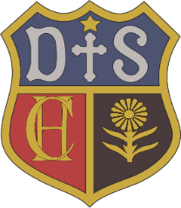

Charlton House Independent School
MFL

Intent

The intention of the MFL curriculum is that children develop a love of learning French in a way that is enjoyable, stimulating and fun. We encourage children’s confidence and creative skills, through songs, stories and games and strive to stimulate and encourage children’s curiosity about language and help them develop an awareness of cultural differences in other countries. We aim to embed the skills of listening, speaking, reading and writing to enable children to use and apply their French learning in a variety of contexts and lay the foundations for future language learning.

