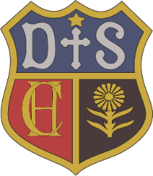

Charlton House Independent School
History
Intent

From The Great Fire of London, to the Titanic. From the Mayans to the Stone Age. From learning all about the lives of the Egyptian’s to the in depth study of World War 1; an essential part of our focus as a catholic school is on the importance of the development of the whole child. Through our history curriculum, we aim to enable our pupils to live successfully in our society with a deep understanding of our cultural heritage as well as an ability to understand the perspectives of others. We will seek to help pupils gain knowledge and understanding of Britain’s past and that of the wider world. This will allow children to explore the cultural identities of the past and begin to recognise how this affects our cultural identity in the present. History skills will be incorporated in to and developed through a range of history topics beginning with content that is relatable for our youngest pupils and becoming more unfamiliar as they progress through Key Stage 2. Immersion is a key factor in our History curriculum, to allow them to fully gain the knowledge and understanding to foster deeper thinking as they move up the school. A good understanding of chronology is important for our students to place new information into context and build upon their previous knowledge. Our knowledge based curriculum provides for depth and analytical thinking in the higher years of the school. In the lower years, we take on a hands on approach wherever we can, and provide multisensory learning to create a sense of excitement.

