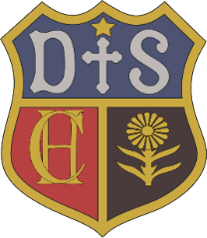

Charlton House Independent School
Computing
Intent

Through our computing curriculum at Charlton House Independent School, we aim to give our pupils the life-skills that will enable them to embrace and utilise new technology in a socially responsible and safe way in order to flourish. We want our pupils to be enthusiastic and able to operate in the ever-changing technological world where work and leisure activities are increasingly transformed by technology. In the 21st century workplace we want them to know the career opportunities that will be open to them if they study computing. We want children to become autonomous, independent users of computing technologies, gaining confidence and enjoyment from their activities focusing on skills such as finding, exploring, analysing, exchanging and presenting information. We want the use of technology to support learning across the entire curriculum and to ensure that our curriculum is accessible to every child including those with special educational needs and disability and those identified as most-able. Not only do we want them to be digitally literate and competent end-users of technology, but through our computer science lessons, we want them to develop wider skills such as creativity, resilience, problem-solving and critical thinking. Our ambition is that all our pupils have a breadth of experience to develop their understanding of themselves as individuals within their community, but also as members of a wider global community and as responsible digital citizens. We believe that all have the ability to achieve their best and our curriculum and varied choice of pedagogy enables all children to do this.

