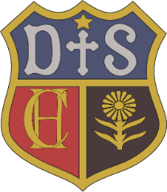

Charlton House Independent School
Art and Design
Intent
An essential part of our focus as a school is on the importance of the development of the whole child. Art is central to this and will seek to inspire all pupils in a search for excellence in art and instil an appreciation and understanding of creativity and imagination as part of a broad and balanced curriculum that includes high-quality arts and culture. This is a vital part of developing our pupils’ creativity, inspiring future careers, and enriching their childhood. For many people, art and creativity is not only a form of expression; it is therapeutic and a form of stress relief and is therefore essential in providing nurture and supporting the wellbeing of our children.

- Art, craft, and design embody some of the highest forms of human creativity. At Charlton House Independent School, we intend to provide a high-quality art and design education that will engage, inspire and challenge pupils, equipping them with the knowledge and skills to experiment, invent and create their own works of art, craft and design.

- As pupils progress, they should be able to think critically and develop a more rigorous understanding of art and design. They should also know how art and design both reflect and shape our history, and contribute to the culture, creativity, and wealth of our nation.

3.The art curriculum will recognise the importance of inclusivity and activities will be adapted to meet the individual needs of all pupils. All pupils have the opportunity to access a range of different art, craft and design activities during their time at Charlton House Independent School and should leave the school with the necessary knowledge and skills to invent and create their own works of art as well as a respectful appreciation for art and creativity. Whilst the art curriculum will be accessible to all pupils, it should be recognised that children have strengths in different subject areas and talented artists should be identified and celebrated.

